**Installation Steps of Atmel Studio in Micro Soft Window 10**

1. Run the setup. Select “I Agree to the license terms and conditions” and Click on the “Next” button.

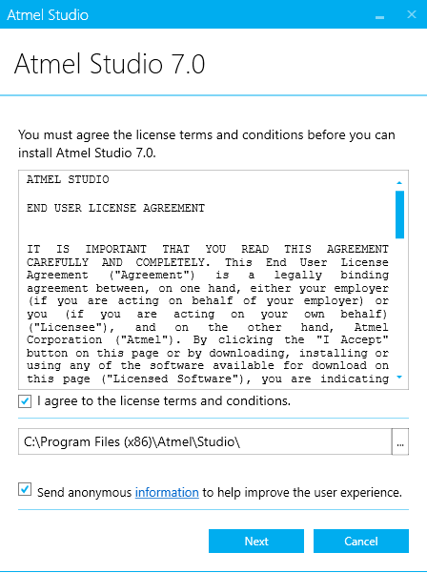

1. Select the Necessary Architectures you would like work with. Click on “Next” button.

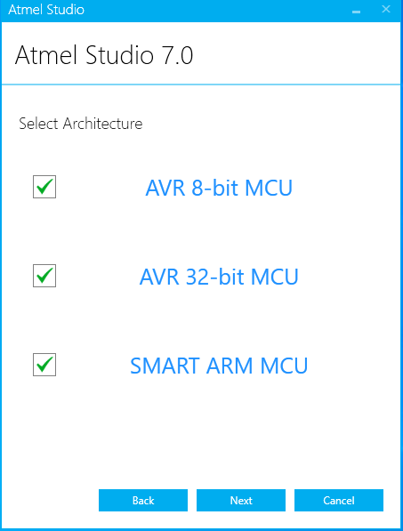

1. Select “Extensions” if you need example projects to start with. Click on “Next” button.

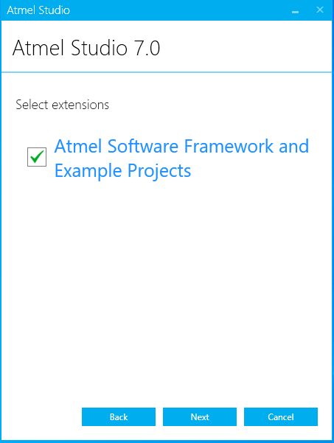

1. Select all “System Validation” option and Click on the “Next” button.

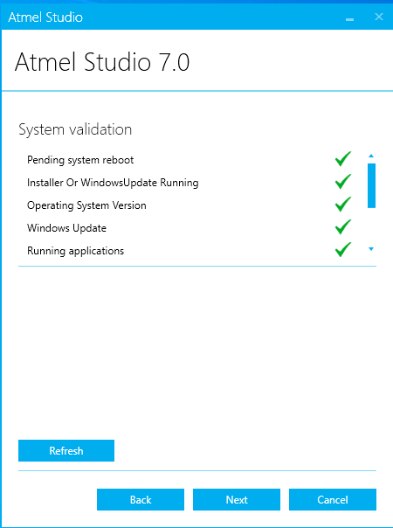

1. Click on the “Install button.

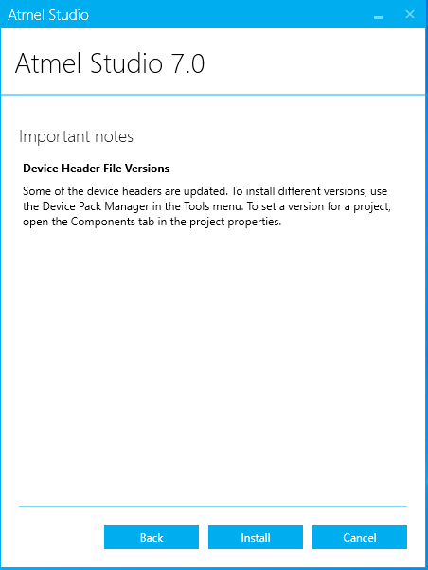

1. Installation will take some time according to system performance

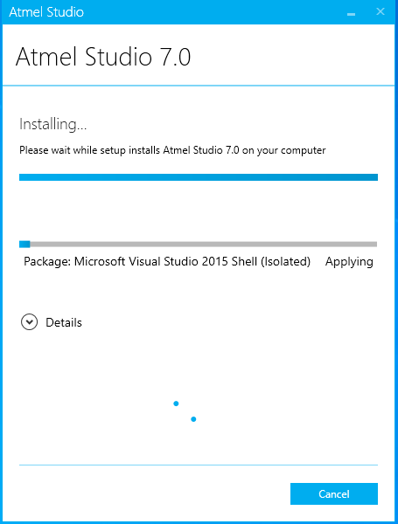

1. If Microsoft Visual Studio 2015 already Installed in Computer then automatically applying Microsoft Visual Studio 2015 Shell (isolated) package. Take a few minute.

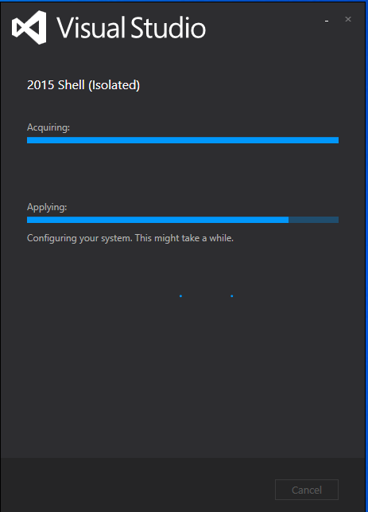

1. Installation Complete and Tick the Check Box “Launch Atmel Studio” . Click on the “Close” button.

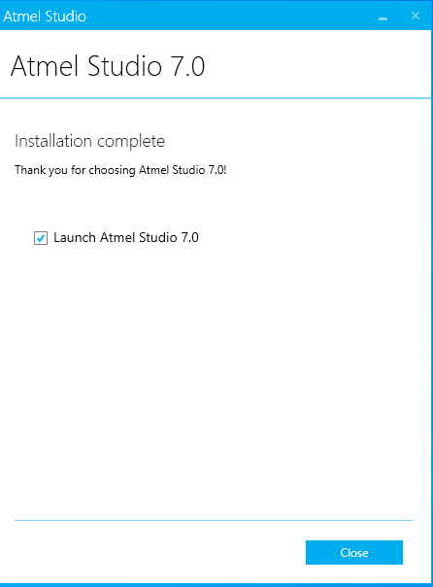

1. The preview as Below:

